w



E-13, UPSIDC Site-IV, Kasna Road, Greater Noida - 201308, India

Phone: +91.120.4296878 | Website: [www.khuranaandkhurana.com www.iiprd.com](http://www.khuranaandkhurana.comwww.iiprd.com/) Email: [info@khuranaandkhuraana.com](mailto:info@khuranaandkhuraana.com) | [iiprd@iiprd.com](mailto:iiprd@iiprd.com)

Indian Offices: Noida | New Delhi | Bangalore | Mumbai | Pune | Mumbai | Hyderabad

|Jalandhar | Chennai

International Offices: US |Bangladesh | Sri Lanka | Malaysia | Vietnam | Myanmar | Nepal | Malaysia

# INVENTIVE DISCLOSURE - CONFIDENTIAL

1. **Proposed Title of the Invention** (Not more than 10 to15 words)

Infant Health Guard Tracking with “YOSO” Speech Detection & Face Expression Recognition.

1. **Proposed Abstract of the Invention** (Kindly explain the crux of the invention in about150 to 200 words.)

# This paper presents a novel infant health monitoring system designed specifically for babies in

# incubators, where the presence of multiple infants makes regular monitoring by hospital staff challenging. The key innovation of this project lies in enhancing baby security by distinguishing between strangers and relatives near the crib. This is achieved through the implementation of the YOSO speech algorithm, which involves creating a dataset comprising voices of individuals related and unrelated to the baby to ensure protection. We have created our own infants sample datasets and that contributes to our novelty.

# The study explores the application of facial recognition techniques in this context,involving the compilation and pre-processing of a varied dataset of infant facial images.Features like facial landmarks and color distribution are extracted from these images, and machine learning methods, particularly Convolution neural networks (CNNs), areemployed to train and test a model for better accuracy. Also there is a Stranger alarm which notifies whether the baby in the incubator has been carried away a certain distance.This alarm works with the integration of Esp32 Microcontroller.

# Key Words:

# Infant Health Monitoring, YOSO Speech Detection, Facial Expression Recognition, CNN (Convolutional Neural Networks),Real-Time Monitoring, Stranger Alert System, Machine Learning, Infant Security, Edge ML Algorithms,EPS32 Microcontroller

# Background of the Invention:

**What are the present technologies that exist in the field of your invention and what are the limitations of the same? (Present state of Art)**

Current technologies within the area of infant monitoring systems cannot be said to offer sophisticated methods of monitoring a baby’s overall condition other than some GSM based systems and rudimentary Arduino systems which can only monitor a few parameters including temperature, humidity and pulse rate and do not offer a real time possibility [1][2]. Some systems are designed for vital health indicators, and they do not possess the capability to analyze the emotional state of the person or the security component of the mirror [3][4]. For example, the wearable infant health monitoring systems have issues with comfort and products’ sturdiness[5] Since currently, there are numerous techniques for facial recognition[6], the proposed technique is to improve upon the shortcomings of the existing robustness for such applications. While there are more modern algorithms such as CNNs and the YOSO model, the implementation of such algorithms in capable, all-embracing infant monitoring systems is relatively rare, which prevents efficient solutions to meet significant emotional and security-related challenges [7][8]. Moreover, some of the proposed solutions fail in meeting the latency demands that is important in neonate healthcare settings.

**Literature Review**

Many researches show that contemporary approaches to monitor infants have notable deficiencies, which create a demand for better methods. In their study, Shabeeb et al. [1] state that most of the simple monitoring systems, especially those GSM based, do not offer continuous full time monitoring and exclude many fundamental parameters but temperature and humidity only. It means that at this level, the care remains limited in a way that hampers the improvement of the general health of infants in critical care settings. The work done by the Department of Electronics and Communication Engineering [2] shows that although the gsm-based solutions can monitor the vital signs, social/emotional states of the infants which are very important for complete monitoring are not handled sufficiently.

Lin et al. [3] also analyze the disadvantages of existing approaches to facial expression recognition more detail and noticed that many methods which are currently used ignore the fact of the difficulties connected with the recognition of infant faces, including their expressiveness and differed features. These drawbacks reduce the efficiency of evaluations of an infant that requires a proper assessment of the child’s condition. Moreover, Mohamad Ishak et al. [4] point out that Arduino-based systems do not have the right mechanisms to enable detailed remote monitoring; this hinders the chances that healthcare organisations will be able to adapt quickly to dynamic conditions.However, the real concern that research focuses on is the ability of these wearable infant health monitoring systems to be as comfortable as well as long-lasting in the sense that they can be worn for extended durations in often fragile settings. According to the latest literature, the synergy of elaborate monitoring systems, encompassing CNNs and the YOSO model, is still limited. Thus, an urgent need arises to come up with unique approaches to not only track one’s biological state of health but also emotional and security response as well; this is about improving the safety of infants in childcare facilities.

# What problems does the invention address and how your Invention is able to overcome the limitations/ problems of the existing technologies?

The invention is aimed at the seemingly and acute problems that are associated with the observation of infants in incubators with reference to numerous such incubators in a particular area. Traditional systems have several limitations that our advanced infant health monitoring system overcomes:

* **Inadequate Real-Time Monitoring and Limited Scope of Monitoring Parameters:** Modern systems that are based on GSM technology or even bare amateur Arduino monitoring have a very strict and narrow coverage and, for the most part, can monitor only several crucial parameters, such as temperature, humidity, and pulse rate, but cannot offer full-time monitoring. The above shortcoming is taken care of in our system by integrating speech recognition, facial monitoring, and a stranger alert system to ensure a comprehensive monitoring medium. Thus, with YOSO speech detection and CNN-based face identification algorithms, as well as increased sensitivity microphones and high-definition cameras, the entire human health and security parameters in real time can be continuously and effectively monitored [1][3].
* **Delayed Response to Critical Conditions:** Inaccurate systems, which can only generate regular or ad hoc alerts, can cause delays between detection of critical conditions, including the mood swings of an infant, intruders, or any other malicious intent. To counter this, our system incorporates Edge ML algorithms that have low latency and high accuracy, quickly sending alerts to the caregiver to take necessary action to protect the infants from critical conditions [8]. The independent EPS32 microcontroller controls the processing of the signals and the detection of critical events in real time and sends notifications.
* **Lack of Emotional State Monitoring and Security Concerns:** The presently employed infant monitoring systems do not commonly incorporate the capability of inferring and categorizing infants’ emotions, which are critical to determining the condition of infants, nor are existing monitoring systems adequate concerning the security and protection of infants from unauthorized interaction. Our invention does this by basing it on a CNN-based facial recognition system to detect and analyze such aspects as happiness, sadness, drowsiness, and crying, apart from the basic signs of infant well-being such as heartbeat and oxygen levels [4]. Additionally, the integration of a stranger alert system through speech recognition to check for unauthorized persons improves the security of the infant.
* **High Latency and Inaccuracy in Existing Solutions:** The choice of solutions has its drawbacks: high latency and inaccuracy, which are dangerous in the contexts of the neonatal environment, where speed and accuracy are vital. Our invention employs optimized Edge ML techniques to manage real-time and near real-time audio and video information processing to provide fast and accurate alerting, thus helping caregivers receive precise and timely information about the state of the infants [7].
* **Enhanced Caregiver Awareness:** Sometimes caregivers are not promptly informed of the status of the infants, hence important interventions are delayed. The alerts are done through Wi-Fi in real-time, making the caregivers always updated on the infants’ condition and what actions to take next, offering peace of mind [6]. The ability of the system to capture sounds and audio that is around the crib of the infant, and the real-time processing provided by the EPS32 microcontroller will enable the caregivers to know of the problems that may be there, thereby protecting the infants’ safety and health.

# Detailed Explanation of the Invention along with working examples. Kindly provide an elaborated description of each and every aspect of the invention (product and/or process) in great detail.

This work aims to develop an advanced infant health monitoring system designed for incubators to ensure the safety and well-being of infants, particularly in environments with multiple infants. The proposed system incorporates speech recognition, facial expression monitoring, and a stranger alert mechanism to provide security and health monitoring. The Fig.1 is divided into four distinct phases, each representing a critical part of the system development and implementation:

**Phase 1: Data Collection and Dataset Development**

* Speech dataset of the relatives and care takers to train the YOSO speech algorithm.
* Facial expression of infant dataset to train the CNN for the emotion recognition and annotated their facial expressions for classification of emotional states using Robo flow.

**Phase 2: Implementing the Monitoring system**

* Implement the YOSO speech detection algorithm using audio capture devices (high-sensitivity microphones) to recognize authorized and unauthorized voices.
* Develop the CNN-based facial recognition system using video capture devices (high-definition cameras) to monitor infant emotions in real-time.
* Embedded the EPS32 to manage the stranger alert alarm mechanism.

**Phase 3: Incorporating the Optimized Edge ML Algorithm**

* Create an Edge ML algorithm to process the collected audio and video data efficiently.
* The algorithm can accurately predict emotional states such as sleep, happy, normal and cry and identify unauthorized presence near the crib.
* Optimize the algorithm for low latency and high accuracy to provide real time alert.

**Phase 4: Product design and Testing**

* Product design and testing the prototype by implementing it on infant crib mobile application and the EDGE impulse platform.

**Functionalities**

* To detect emotions such as happiness, sadness, sleepiness, and crying to monitor the infant's well-being.
* To detect the sounds and audio surrounding the infant’s crib to monitor the infant’s safety with real time processing managed by the EPS32 microcontroller.
* To provide caregivers with real-time alerts via Wi-Fi for constant awareness of the infant’s safety and well-being.

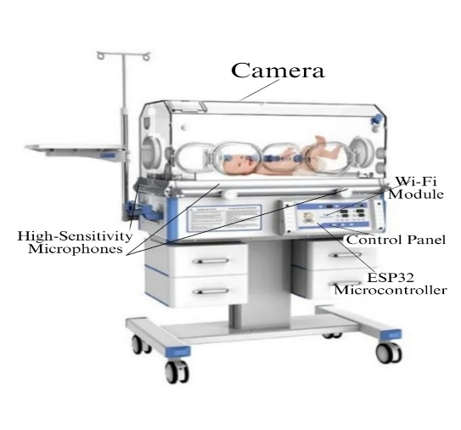

**Fig 1: Smart Infant System**

# Kindly attach drawings, reports, papers, charts or other materials that may aid in your description.

**Main flowchart :**

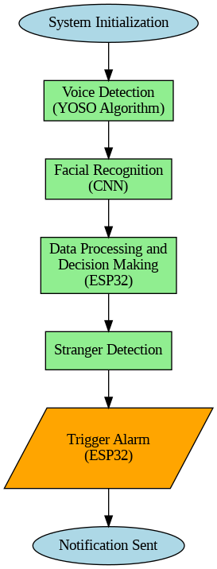

**Voice detection diagram:**

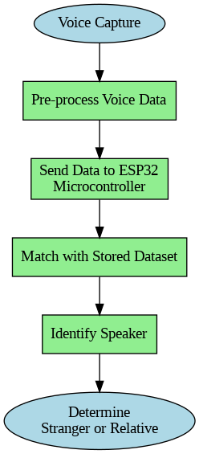

# Facial recognition diagram:

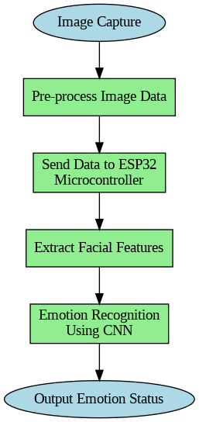

# Alarm trigger flowchart

# 

# Sample output of the facial expression recognition i.e. CNN

# 

# Smart infant monitoring

# 

# What are the aspects of your disclosure that you want to claim/monopolize?

The aspects of our disclosure that we wish to claim and monopolize include:

* **Integrated Monitoring System:** The integration of speech recognition as well as monitoring of facial expressions and stranger alert mechanisms, suitable for monitoring the health of infants in incubators [1].
* **YOSO Speech Detection Algorithm:** The unique YOSO speech detection algorithm for real-time identification of permitted and prohibited utterances as well as for increasing security and the level of knowledge about a patient’s needs for a caregiver [7].
* **CNN-Based Facial Recognition:** The application of state-of-art technique of CNN analysis for real time monitoring of infants’ emotions such as happiness, sadness, sleepiness and crying, to know the infant’s condition in a better way [3].
* **Optimized Edge ML Algorithms:** It also gets the optimized Edge ML algorithms which enable the real-time response with low latency and high accuracy in the processing of sound and vision data for timely alerting and monitoring [6].
* **EPS32 Microcontroller Integration:** The timeliness in processing and alert series where EPS32 microcontroller – for the first time – is used in managing the real – time control and caregiver notification options in emergency [4].
* **Holistic Health and Security Monitoring:** The possibility to simultaneously observe a variety of health and security factors, which eliminates the drawbacks of contemporary systems aimed at individual indexes [2].

# Have you conducted novelty/inventiveness search for your invention? If yes, what are the databases /references used by you? What are the search results?

# Yes, a novelty and inventiveness search for the invention was done as part of an overall search. The databases used consist of: IEEE Xplore, Google Scholar; as well as Conference and Journal in the area of infant care, medical devices and artificial intelligence. This search brought up the findings that, in comparison with the existing solutions, the primary aspects considered in infant care are heart rate monitoring and temperature sensing: [1][2] Thus, the “You Only Speak Once” (YOSO) algorithm, which differentiates the speaker’s kinship to the baby through identification of voice, is new. This algorithm has not been recorded in the indexed databases and literature; hence, this research offers a novel approach to assessment of infants’ health.WIHMS-recent literature is still rich in pointing out various disadvantages that existing technologies have, including their comfort, accuracy, sturdiness, and protection [3]. On the other hand, the YOSO algorithm uses the dataset of voices, including those belong to individuals connected to the baby and those not, to have a solid foundation in improving security and to help the healthcare practitioners in automating the process of monitoring the baby. Furthermore, though, there is a look at the facial recognition techniques that have been applied in the monitoring of the health of infants [4][5], it is a fact that using the advanced techniques along with the integration of the YOSO algorithm enhances a comprehensive monitoring system. This combination gives alerts on time and has greatly improved on the safety and provision of incubation for infants.

# In addition, we employed the UPHC, which contains images of infants’ faces and recordings of parents and guardians. To collect data, the best ethical ways and means were followed because data constitutes a significant factor in developing the YOSO speech algorithm and certification of the face recognition modules appended to the invention while making it and efficient and dependable.

# Do you feel that a person of “average” skill (not-extraordinary skill) in your areaof technology would have arrived at your invention with existing knowledge in public domain? If no, what could be the reasons for the same?

# No, an average skilled person could not have arrived at my invention for the following reasons. It incorporates such high-end solutions as the YOSO algorithm for voice identification and CNN-based face identification that do not remain indifferent to professional knowledge. Also, it is mentioned that the YOSO algorithm is new, and there is no record of such an algorithm in the previous works; and the process of developing specific datasets is cumbersome. The sysytem also requires a low latency, high accuracy of monitoring of neonates not only with respect to their emotions but also with respect to security, for which the solution is not intended.

# Kindly provide broad workable ranges for all the parameters involved in yourinvention.

* **YOSO Audio Sampling Rate:** Approximately 8 MB
* **Dataset Image Resolution:** 128 to 512 pixels
* **Feature Extraction:** Utilize machine learning or deep learning approaches
* **Convolution Layers:** 2 to 5 layers with filter sizes ranging from 3x3 to 7x7
* **Learning Rate:** Between 0.001 and 0.1
* **Pooling Layer Sizes:** 2x2 or 3x3
* **Activation Function:** ReLU

1. **References (if any)**

[1] Shabeeb, Ali Ghazi, et al. ‘Remote Monitoring of a Premature Infants Incubator’. Indonesian Journal of Electrical Engineering and Computer Science, vol. 17, no. 3, Mar. 2020, p. 1232. DOI.org (Crossref), <https://doi.org/10.11591/ijeecs.v17.i3.pp1232-1238>.

[2] Department of Electronics and Communication Engineering, Kongu Engineering College, Perundurai, India, et al. ‘Baby Incubator Monitoring System Using Global System for Mobile Technology’. Jurnal Kejuruteraan, vol. 34, no. 5, Sept. 2022, pp. 899–904. DOI.org (Crossref), <https://doi.org/10.17576/jkukm-2022-34(5)-17>.

[3] Lin, Qing, et al. ‘Feature Guided CNN for Baby’s Facial Expression Recognition’. Complexity, edited by Min Xia, vol. 2020, Nov. 2020, pp. 1–10. DOI.org (Crossref), <https://doi.org/10.1155/2020/8855885>

[4] Mohamad Ishak, Daing Noor Farhanah, et al. ‘Arduino Based Infant Monitoring System’. IOP Conference Series: Materials Science and Engineering, vol. 226, Aug. 2017, p. 012095. DOI.org (Crossref), <https://doi.org/10.1088/1757-899X/226/1/012095>.

[5] ‘AN INFANT FACIAL EXPRESSION RECOGNITION SYSTEM BASED ON MOMENT FEATURE EXTRACTION’: Proceedings of the International Conference on Computer Vision Theory and Applications, SciTePress - Science and and Technology Publications, 2010, pp. 313–18. DOI.org (Crossref), <https://doi.org/10.5220/0002814403130318>.

[6] Asmidar, Nor, et al. ‘Development of Infant Incubator for Clinic in the Rural Area of Malaysia’. 2016 IEEE EMBS Conference on Biomedical Engineering and Sciences (IECBES), IEEE, 2016, pp. 331–34. DOI.org (Crossref), <https://doi.org/10.1109/IECBES.2016.7843468>.

[7] Cascudo, I., David, B., Garms, L., & Konring, A. (2022, December). YOLO YOSO: fast and simple encryption and secret sharing in the YOSO model. In International Conference on the Theory and Application of Cryptology and Information Security (pp. 651-680). Cham: Springer Nature Switzerland.

[8] Zamir, Muhammad, et al. ‘Face Detection & Recognition from Images & Videos Based on CNN & Raspberry Pi’. Computation, vol. 10, no. 9, Aug. 2022, p. 148. DOI.org (Crossref), https://doi.org/10.3390/computation10090148.

# Inventors Details (Full Names, Nationality and Addresses)

1. **Applicant Details (Full Names, Nationality and Addresses)**

# Any additional notes or remarks.

1. **For Life Sciences related inventions:**

# Provide source and geographical origin of the biological material/resource (for e.g. plants, animals, micro-organisms, their parts / genetic material andby-products with actual or potential use or value)

* 1. **Please note, if the biological material used in the invention is from India, then an application to seek approval of the National Biodiversity Authority(NBA) for applying for intellectual property rights (including patents) in or outside India needs to be made as per the Biological DiversityAct, 2002.**

# Please indicate in case you need assistance to make an application to theNBA.

**Yes/No**

# Please provide sequence listing in computer readable format.

* 1. **In case you would like us to prepare the sequence listing for submission to the Patent Office please indicate**

# Yes/No

* 1. **Please indicate if the invention relates to novel biological material for example, bacteria, fungi, eukaryotic cell lines, plant spores, genetic vectors (such as plasmids or bacteriophage vectors or viruses) containing a gene or DNA fragments, or organisms used for expression of a gene (making the protein from the DNA).**

# Yes/No

* 1. **If Yes, have you deposited material with the recognized depositary under** **the Budapest Treaty?**

# Yes/No

**(Please note, in case of novel material as mentioned above, deposition mustbe made before filing of the patent application).**